A penguin’s shadow

Light from a small bright lamp is shining on a screen.
A toy penguin is put half way between the lamp and the screen.

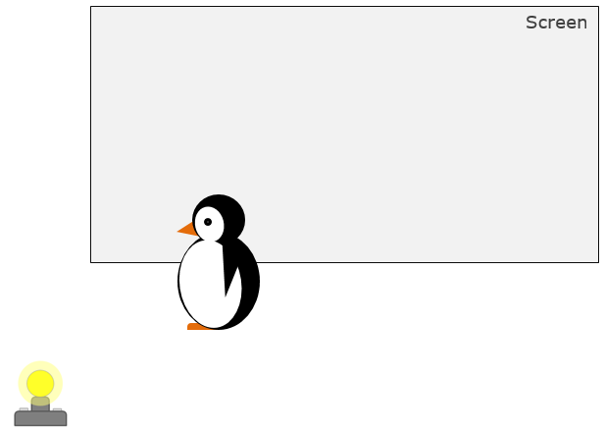

What would you see on the screen?
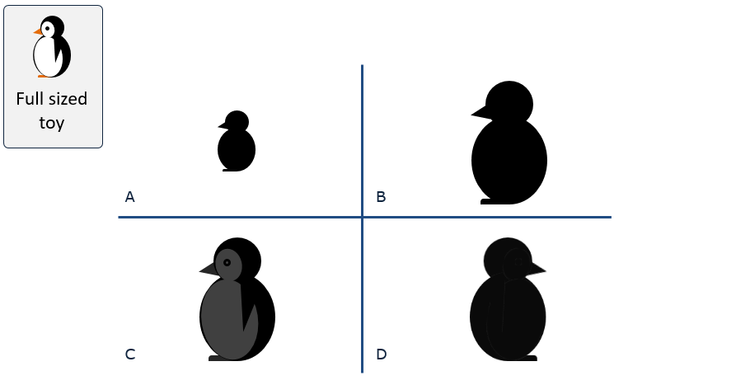

Cardboard cut-out (if required to demonstrate)


Physics > Big idea PSL: Sound, light and waves > Topic PSL1: Sound and light > Key concept PSL1.2: Characteristics of light
Diagnostic question
A penguin’s shadow

Overview
Learning focus: | Light travels in straight lines at very high speeds.
Observable learning outcome: | Identify the shadow made by an object.
Question type: | Simple multiple choice
Key words: | Shadow, straight-line

P | PRIOR UNDERSTANDING  This diagnostic question probes understanding of ideas that are usually taught at age 5-11, to aid transition from earlier stages of learning.

What does the research say?
Students will probably have learned about how shadows are formed in their earlier studies. This question checks whether students have retained any enduring misunderstandings about shadows.
Guesne (1985) found many students aged 10-11 viewed shadows as a reproduction of an object’s shape. Young children confuse ‘shadow’ and ‘reflection’ and may draw faces on a shadow. Some may think a shadow is part of an object which is made visible by light.
By age 14 Guesne found the majority of students recognised light as an entity and could use this notion to explain shadows in bright light. She also found that many did not think shadows formed when the light was less than bright.
Ways to use this question
Students should complete the question individually. This could be a pencil and paper exercise, or you could use an electronic ‘voting system’ or mini white boards and the PowerPoint presentation.
The answers to the question will show you whether students understood the concept sufficiently well to apply it correctly.
If there is a range of answers, you may choose to respond through structured class discussion. Ask one student to explain why they gave the answer they did; ask another student to explain why they agree with them; ask another to explain why they disagree, and so on. This sort of discussion gives students the opportunity to explore their thinking and for you to really understand their learning needs.
Differentiation
You may choose to read the questions to the class, so that everyone can focus on the science. In some situations it may be more appropriate for a teaching assistant to read for one or two students.

Expected answer
Answer B
How to respond - what next?
Light spreads out from the lamp and is blocked by the toy.
Answer A is a simple reproduction which suggests students are answering from experience and not thinking through how the shadow forms. Alternatively, shadow A is formed if the light is in a parallel beam.
Answer C is a naïve understanding that confuses a shadow with a reflection, as is answer D.
If students have misunderstandings about what the shadow should look like, it can help to demonstrate what happens with a bright light source and a cardboard cut-out of the penguin.
The following BEST ‘diagnostic question’ and ‘response activity’ could be used to investigate and develop students’ understanding of how shadows are formed:
Diagnostic question: Making a shadow
Response activity: Extra light shadow
Acknowledgments
Developed by Peter Fairhurst (UYSEG), from York Science activity PLC1.2a by Mary Whitehouse (UYSEG).
Images: UYSEG
References
Guesne, E. (1985). Light. In Driver, R., Guesne, E. & Tiberghien, A. (eds.) Children's Ideas in Science. Milton Keynes: Open University Press.

